**DAILY ASSESSMENT**

|  |  |  |  |
| --- | --- | --- | --- |
| **Date:** | **17/06/2020** | **Name:** | **Dhavala** |
| **Course:** | **Statistical Learning** | **USN:** | **4AL17EC027** |
| **Topic:** | * **Introduction to probability** * **Rules for probability calculation** | **Semester & Section:** | **6TH SEM & A Section** |
| **Github Repository:** | **Dhavala27** |  |  |

|  |
| --- |
| **SESSION DETAILS** |
|  |

|  |
| --- |
| **Report** |

|  |  |  |  |
| --- | --- | --- | --- |
| **Date:** | **17/06/2020** | **Name:** | **Dhavala** |
| **Course:** | **Statistical Learning** | **USN:** | **4AL17EC027** |
| **Topic:** | * **Bayes’ Theorem** * **Normal Distribution** | **Semester & Section:** | **6TH SEM & A Section** |
| **Github Repository:** | **Dhavala27** |  |  |

|  |
| --- |
| **SESSION DETAILS** |
|  |

|  |
| --- |
| **Report** |

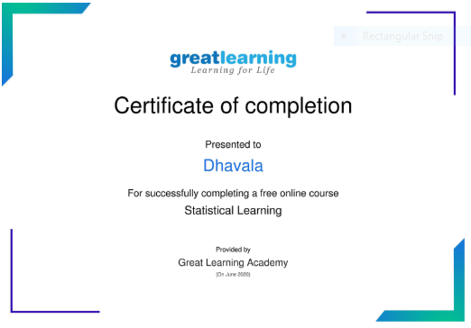

|  |  |  |  |
| --- | --- | --- | --- |
| **Date:** | **17/06/2020** | **Name:** | **Dhavala** |
| **Course:** | **EMURGO** | **USN:** | **4AL17EC027** |
| **Topic:** | **Break the Chain Socially & Connect the Chain by Building Blocks & Career** | **Semester & Section:** | **6TH SEM & A Section** |
| **Github Repository:** | **Dhavala27** |  |  |

